Template for Evidence(s)
UI GreenMetric Questionnaire

University : ...
Country : ...
Web Address : …

[1] Setting and Infrastructure (SI)
SAMPLE
[1.9] Total area on campus covered in forest vegetation used for research, teaching, and/or community engagement (meter²) (SI.2)

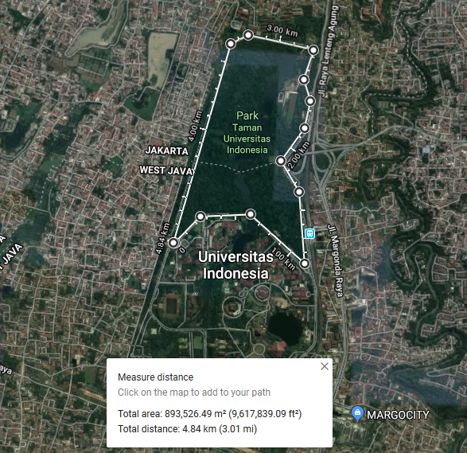
Example of Total Forest Vegetation Area (Universitas Indonesia, Indonesia)

Description:
(Please describe the forest vegetation used for research, teaching, and/or community engagement area in your campus. The following is an example of the description. You can describe more related items if needed.)

The evidence provided may also include maps showing the location, area size, or distribution of facilities relevant to the indicators

Total area: 893,529,49 m²
Total distance/circumference: 4.84 km

Additional evidence link (i.e., for videos, more images, or other files that are not included in this file):

